**Project Design Phase-II**

**Technology Stack (Architecture & Stack)**

|  |  |
| --- | --- |
| Date | 14 April 2025 |
| Team ID | 145206 |
| Project Name | Sociopedia |
| Maximum Marks | 4 Marks |

**Technical Architecture:**

The Deliverable shall include the architectural diagram as below and the information as per the table1 & table 2

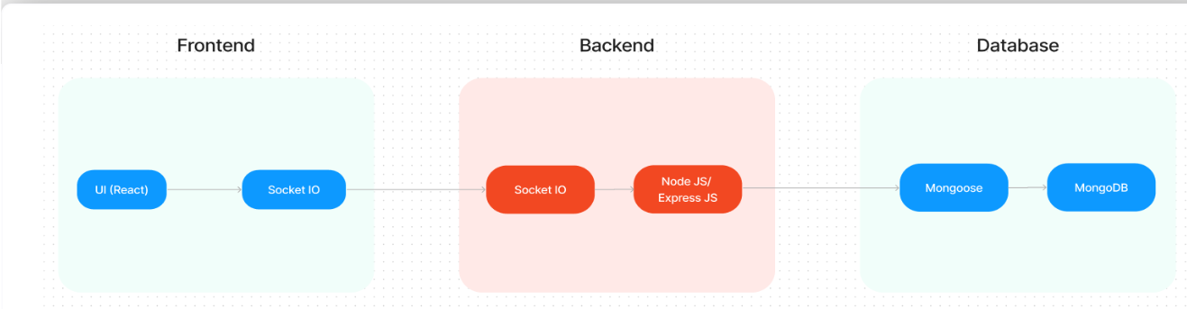

**Table-1 : Components & Technologies:**

| **S.No** | **Component** | **Description** | **Technology/Service** |
| --- | --- | --- | --- |
| **1.** | **User Interface** | **Responsive web app with real-time updates.** | **React.js, Material-UI, Socket.IO** |
| **2.** | **Application Logic-1** | **Authentication (JWT, OAuth).** | **Node.js, Express.js, Passport.js** |
| **3.** | **Application Logic-2** | **Post handling (CRUD, notifications).** | **Node.js, Express.js** |
| **4.** | **Database** | **User profiles, posts, friend lists.** | **MongoDB Atlas** |
| **5.** | **File Storage** | **Image/video uploads.** | **Cloudinary/AWS S3** |
| **6.** | **External API-1** | **Social login (Google/Facebook).** | **Firebase OAuth** |
| **7.** | **External API-2** | **Email notifications.** | **SendGrid/Mailgun** |
| **8.** | **Infrastructure** | **Scalable cloud deployment.** | **AWS EC2, Kubernetes** |

**Table-2: Application Characteristics:**

| **S.No** | **Characteristics** | **Description** | **Technology/Approach** |
| --- | --- | --- | --- |
| **1.** | **Open-Source Frameworks** | **Frontend/backend libraries.** | **React, Express, Mongoose** |
| **2.** | **Security** | **Encryption, rate limiting, OWASP guidelines.** | **bcrypt, JWT, Helmet.js** |
| **3.** | **Scalable Architecture** | **Microservices-ready, load balancing.** | **Docker, Kubernetes** |
| **4.** | **Availability** | **99.9% uptime with failover.** | **AWS Multi-AZ, MongoDB ReplicaSet** |
| **5.** | **Performance** | **Caching, CDN, optimized queries.** | **Redis, React.memo, CDN (CloudFront)** |

**References:**

[**https://c4model.com/**](https://c4model.com/)

[**https://developer.ibm.com/patterns/online-order-processing-system-during-pandemic/**](https://developer.ibm.com/patterns/online-order-processing-system-during-pandemic/)

[**https://www.ibm.com/cloud/architecture**](https://www.ibm.com/cloud/architecture)

[**https://aws.amazon.com/architecture**](https://aws.amazon.com/architecture)

[**https://medium.com/the-internal-startup/how-to-draw-useful-technical-architecture-diagrams-2d20c9fda90d**](https://medium.com/the-internal-startup/how-to-draw-useful-technical-architecture-diagrams-2d20c9fda90d)